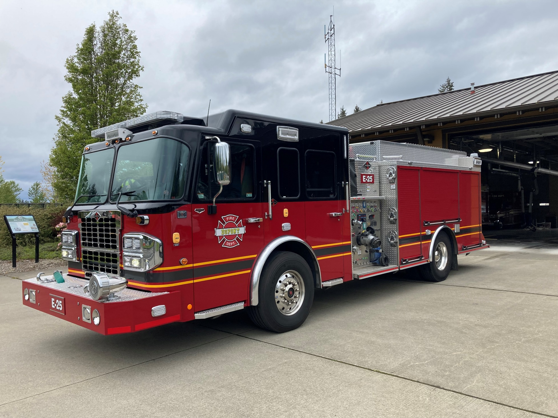

City of DuPont Fire Department
First Half of 2025

The Misson of the Dupont Fire Department is to provide professional service with Compassion and Integrity

Efficient Response-Flawless Performance-Compassionate Actions

Prepared by Larry Creekmore, Assistant Fire Chief

Incident Type | 2022 | 2023 | 2024 | 2025
(10) Fire, other | 2 | 2 | 0 | 1
(11) Structure Fire | 3 | 3 | 1 | 3
(13) Mobile property (vehicle) fire | 3 | 3 | 2 | 4
(14) Natural vegetation fire | 2 | 4 | 6 | 2
(15) Outside rubbish fire | 1 | 0 | 1 | 1
(16) Special outside fire | 0 | 0 | 1 | 1
(25) Excessive heat, scorch burns with no ignition | 1 | 1 | 0 | 0
(30) Rescue, emergency medical call (EMS), other | 0 | 0 | 0 | 0
(31) Medical assist | 0 | 5 | 1 | 1
(32) EMS service incident including vehicle accidents | 300 | 332 | 351 | 352
(33) Lock-In | 0 | 0 | 0 | 0
(34) Search for Lost Person | 0 | 0 | 1 | 0
(35) Extrication, rescue | 4 | 0 | 1 | 1
(36) Water or ice-related rescue | 0 | 1 | 0 | 1
(40) Flammable gas or liquid condition, other | 1 | 0 | 0 | 0
(41) Combustible/flammable spills & leaks | 4 | 5 | 4 | 4
(42) Chemical release, or toxic condition | 0 | 2 | 0 | 1
(44) Electrical wiring/equipment problem | 3 | 1 | 0 | 1
(46) Accident, potential accident | 0 | 0 | 0 | 0
(48) Attempt to burn | 0 | 0 | 1 | 0
(50) Service call, other | 16 | 20 | 24 | 12
(51) Person in distress | 5 | 5 | 4 | 7
(52) Water problem | 3 | 0 | 19 | 1
(53) Smoke, odor problem | 2 | 2 | 1 | 0
(54) Animal problem or rescue | 0 | 0 | 0 | 1
(55) Public service assistance | 15 | 19 | 21 | 33
(56) Unauthorized burning | 0 | 1 | 1 | 0
(60) Good intent call, other | 3 | 5 | 1 | 2
(61) Dispatched and canceled en route | 15 | 29 | 18 | 27
(62) Wrong location, no emergency found | 0 | 1 | 0 | 1
(63) Controlled Burning | 0 | 0 | 0 | 1
(65) Steam, other gas mistaken for smoke | 9 | 8 | 9 | 4
(66) EMS call where party was transported prior to arrival | 0 | 0 | 4 | 0
(70) False alarm and false call, other | 8 | 5 | 11 | 4
(71) Malicious, mischievous false alarm | 1 | 0 | 0 | 1
(73) System or detector malfunction | 16 | 18 | 22 | 23
(74) Unintentional system/detector operation (no fire) | 10 | 7 | 17 | 14
(91) Citizen complaint | 0 | 0 | 0 | 0
UNK | 0 | 1 | 0 | 0
Total | 427 | 480 | 519 | 504
*Tables are January to June

Incident Type Year to Date 2022-2025, January to June:

Table-1

Overall Response Times:

Table-2a First Quarter
City Adopted | Time Standard | Average | Success Rate
Dispatch to En-Route | 120 seconds | 97 seconds | 80%
En-Route to On Scene | 360 seconds | 293.5 seconds | 76%
Time from Dispatch to On Scene | 480 seconds | 390.8 seconds | 76.5
NFPA-1710 Time | Time Standard | Our Average | Success Rate
Dispatch to En-Route | 60 seconds | 97 seconds | 22%
En-Route to On Scene | 240 seconds | 293.5 seconds | 36%
Time from Dispatch to On Scene | 340 seconds | 390.8 seconds | 64.3%

Table 2b Secord Quarter
City Adopted | Time Standard | Average | Success Rate
Dispatch to En-Route | 120 seconds | 93.6 seconds | 83%
En-Route to On Scene | 360 seconds | 294 seconds | 76%
Time from Dispatch to On Scene | 480 seconds | 387 seconds | 81%
NFPA-1710 Time | Time Standard | Our Average | Success Rate
Dispatch to En-Route | 60 seconds | 93.6 seconds | 22.2%
En-Route to On Scene | 240 seconds | 294 seconds | 50.7%
Time from Dispatch to On Scene | 340 seconds | 387 seconds | 42%

ALS-Priority Medical Responses -Over all Response Times

Table-3a First Quater
NFPA-1710 Time | Time Standard | Average | 2025
Time from Dispatch to On Scene | 540 Seconds | 345.4 seconds | 91%

Table-3b Second Quater
NFPA-1710 Time | Time Standard | Average | 2025
Time from Dispatch to On Scene | 540 Seconds | 444 seconds | 82%

Occurrences of Mutual Aid:

Table-4a First Quarter

Calls | 2025
Aid Received | 37
Aid Given | 24

Table 4b Second Quarter

Calls | 2025
Aid Received | 44
Aid Given | 18

Transport Destinations:

Table-5

Location | 2022 | 2023 | 2024 | 2025
Allenmore Hospital | 1 | 0 | 1 | 1
Madigan Army Medical Center | 65 | 38 | 52 | 88
Mary Bridge Children’s Hospital | 8 | 10 | 5 | 9
St Clare Hospital | 52 | 41 | 26 | 85
St Joseph Hospital Tacoma | 6 | 9 | 11 | 13
St Peters Providence Hospital | 16 | 5 | 2 | 10
Tacoma General | 5 | 1 | 1 | 10
Wellfound Behavioral Health Hospital | 0 | 0 | 0 | 0
Total | 153 | 104 | 98 | 216

Medical Non-Transport Disposition:

Table-6
Disposition | 2022 |  | 2023 | 2024 | 2025
Assist, Public |  | 5 | 2 | 1 | 1
Cancelled (No Patient Contact) |  | 2 | 0 | 0 | 0
Patient Dead on Scene - No Resuscitation Attempted (Without Transport) |  | 2 | 3 | 1 | 0
Patient Dead on Scene - Resuscitation Attempted (Without Transport) |  | 1 | 3 | 0 | 1
Patient Evaluated, No Treatment/Transport Required |  | 29 | 18 | 43 | 37
Patient Refused Evaluation/Care (Without Transport) |  | 7 | 7 | 37 | 24
Patient Treated, Released (AMA) |  | 16 | 38 | 6 | 8
Patient Treated, Released (per protocol) |  | 13 | 9 | 4 | 5
Patient Treated, Transferred Care to Another EMS Professional/Unit |  | 14 | 32 | 4 | 9
Patient Treated, Transported by Private Vehicle |  | 2 | 0 | 1 | 3
Other/NULL |  | 4 | 2 | 13 | 7
Total |  | 94 | 114 | 110 | 95

